

Coco Mademoiselle

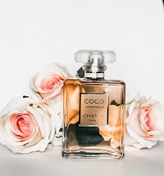

Coco Chanel, the famous French fashion designer and businesswoman launched her eponymous perfume Coco Chanel in 1984. The nose behind the fragrance was Jacques Polge. Since then many variants have been launched by the brand such as Coco Mademoiselle, Mademoiselle Intense and Coco Noir. The original timeless classic perfume remains the industry favorite and still sells at high price points. Check Coco Chanel Perfume Prices in Pakistan on this page and read on for detail on its notes and longevity.

**Notes**

Top notes are Frangipani, Mandarin Orange, Jasmine, Bulgarian Rose, Peach and Coriander. The heart of the perfume contains Orange Blossom, Clover, Mimosa, Rose and Cloves. It dries down to notes of Sandalwood, Vanilla, Amber, Civet, Opoponax, Patchouli, Tonka Bean and Labdanum.

**Longevity & Concentration**

Chanel Coco is an old release by the brand and was launched as an oriental woody scent for bold and vivacious women. It is available in Eau De Perfume concentration. The perfume exudes old Hollywood glamour and has a luxurious tone. It has excellent longevity and will last for up to 10 hours with 3 sprays.

**Product Description**

PRs: **$ 455.66**

Note: Mandarin Orange

Brand Name: Chanel

Perfume Name: Coco Mademoiselle